DC/20/0094/RM

Please can the below be uploaded as a neighbour representation from 37 Bumpstead Road.

Dear Sirs

With reference to the above application I wish to make the following comments:-

**Surface water drainage**:

I would make you aware that on numerous occasions during recent heavy rain surface water can be seen to run down the sides of the platforms and flow overland into the water attenuation park at the rear of our property. It was necessary for us on one occasion to go out and create a water drainage channel to divert the water from the strip of grassland immediately adjacent to our garden fence and into the water park. The site has of course been laid with the addition of lime and cement to stabilise it to allow for the development which is non permeable so the only way for the water is to flow down the sides of the platforms. I cannot, as you will appreciate, understand the ‘jargon’ in much of the documentation in relation to specific issues such as this and, therefore would like to question what measures will be included in the development to mitigate this problem as I would envisage that the hard surfacing needed to the development as a whole will only add to this problem.

**Highways**:

I note with concern the comments from Suffolk Highways in that the proposed development is not policy compliant. Can I ask for confirmation that the Planning Authority will go back to developers and insist that Suffolk Highways minimum requirements are met. Not doing so could well result in cars and or HGV's being parked along Iceni Way and Bumpstead Road causing dangerous situations for both pedestrians and motorists. There is still no continuous footpath along Bumpstead Road which I had been led to believe would be dealt within a S106 Agreement, but this does not appear to have been a condition of any the applications.

**Noise levels**:

All of the noise assessments refer to levels in dB and that night levels may exceed the assessment. As a private individual I have no way of knowing what this means. What will I hear from my house at night? As in early applications all of these assessments are estimated and “in our opinion will not cause significant disruption to neighbouring residential properties”. However, it is an opinion and significant is not defined. Significant to a developer may be very different to significant to a resident. All and any night time activities will impact on noise levels not least with the ‘vehicle reversing systems in all lorries and fork lifts”. I appreciate that these are necessary and indeed required by law but once again the re-orientation of the buildings will mean that local residential properties are now open to ‘significant disruption’ from these activities.

**Lighting**:

Reference is made in the wildlife report to disturbance to bats etc. from lighting. As mentioned above the re-orientation of the buildings layout will result in all local residents being affected by operational and security lighting whether it points up or down above the level of the acoustic fencing. Are there any planning conditions that can be imposed to negate this, such as keeping all exterior lighting below 4 metres from ground level?

**Landscaping**:-

Having spoken to an employee of the on site contractors I understand that the side of the platform facing Bumpstead Road and alongside Unit 3 is to be re-profiled as the original surface is falling away. I cannot see any reference as to how that is going to be dealt with and what will be used to stabilise the new profiling. If this is to be planted presumably this will be part of the overall landscaping maintenance? I cannot see any reference to it in any of the documentation.

**Ecology report**:

This mentions no great crested newts seen in the last 10 years. We have lived here for 10 years and we have seen them in our garden along with slowworms and grass snakes.

Attached to this email are various photographs of the views we have from our property of the ongoing building and development works. As you will see the building on plot 3 is very near to us and what is very distressing is that between us and the building on plot 3 will be a roadway affording access for all motor vehicles. I would hope when looking at these photographs that you will appreciate the level of concerns that I and other residents have in relation to how the new orientation of the buildings on the site will affect us with noise, lighting and also diesel fumes, external machinery such as air conditions units and extractor fans. Very many lorries now have exhaust pipes emitting fumes above cab level. These fumes will then be above the level of acoustic fencing and depending upon wind direction and because of the height of the platforms these particles will then stretch far and wide.

I think what the planning officers and developers have failed to take into consideration is that all people who live on Bumpstead Road, for obvious reasons, live at the rear of their properties. When in our rear gardens we are protected from road noise and pollution by our properties. We will have no such protection from this development and indeed the height of the platforms will increase the “significant disruption". Deciduous trees will offer no protection when they lose their leaves and anything above the top of the acoustic fencing will affect us all greatly. No. 37 is of course at most risk of significant disruption from in particular, but not limited to, all movements on the north and south west sides of unit 3.

I have asked before but at this late stage I appreciate that very little of what I may say will be reflected in decisions made but I would ask the points I have raised be considered in relation to any approval or otherwise of outstanding conditions.

Yours faithfully

Susan Roach (Mrs)

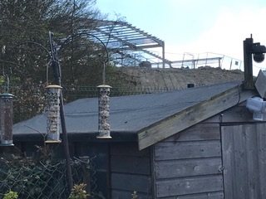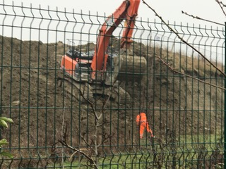

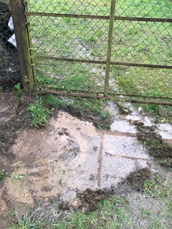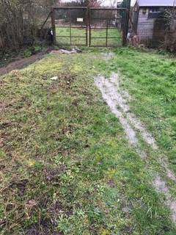

******************************************************************* This email is confidential and intended solely for the use of the individual to whom it is addressed. If you are not the intended recipient, be advised that you have received this email in error and that any use, dissemination, forwarding, printing, or copying of this email is strictly prohibited. If you have received this email in error please contact the Sender. This footnote confirms that this email message has been swept for the presence of computer viruses and content security threats. WARNING: Although the Council has taken reasonable precautions to ensure no viruses are present in this email, the Council cannot accept responsibility for any loss or damage arising from the use of this email or attachments. ********************************************************-W-S-

******************************************************************* This email is confidential and intended solely for the use of the individual to whom it is addressed. If you are not the intended recipient, be advised that you have received this email in error and that any use, dissemination, forwarding, printing, or copying of this email is strictly prohibited. If you have received this email in error please contact the Sender. This footnote confirms that this email message has been swept for the presence of computer viruses and content security threats. WARNING: Although the Council has taken reasonable precautions to ensure no viruses are present in this email, the Council cannot accept responsibility for any loss or damage arising from the use of this email or attachments. ******************************