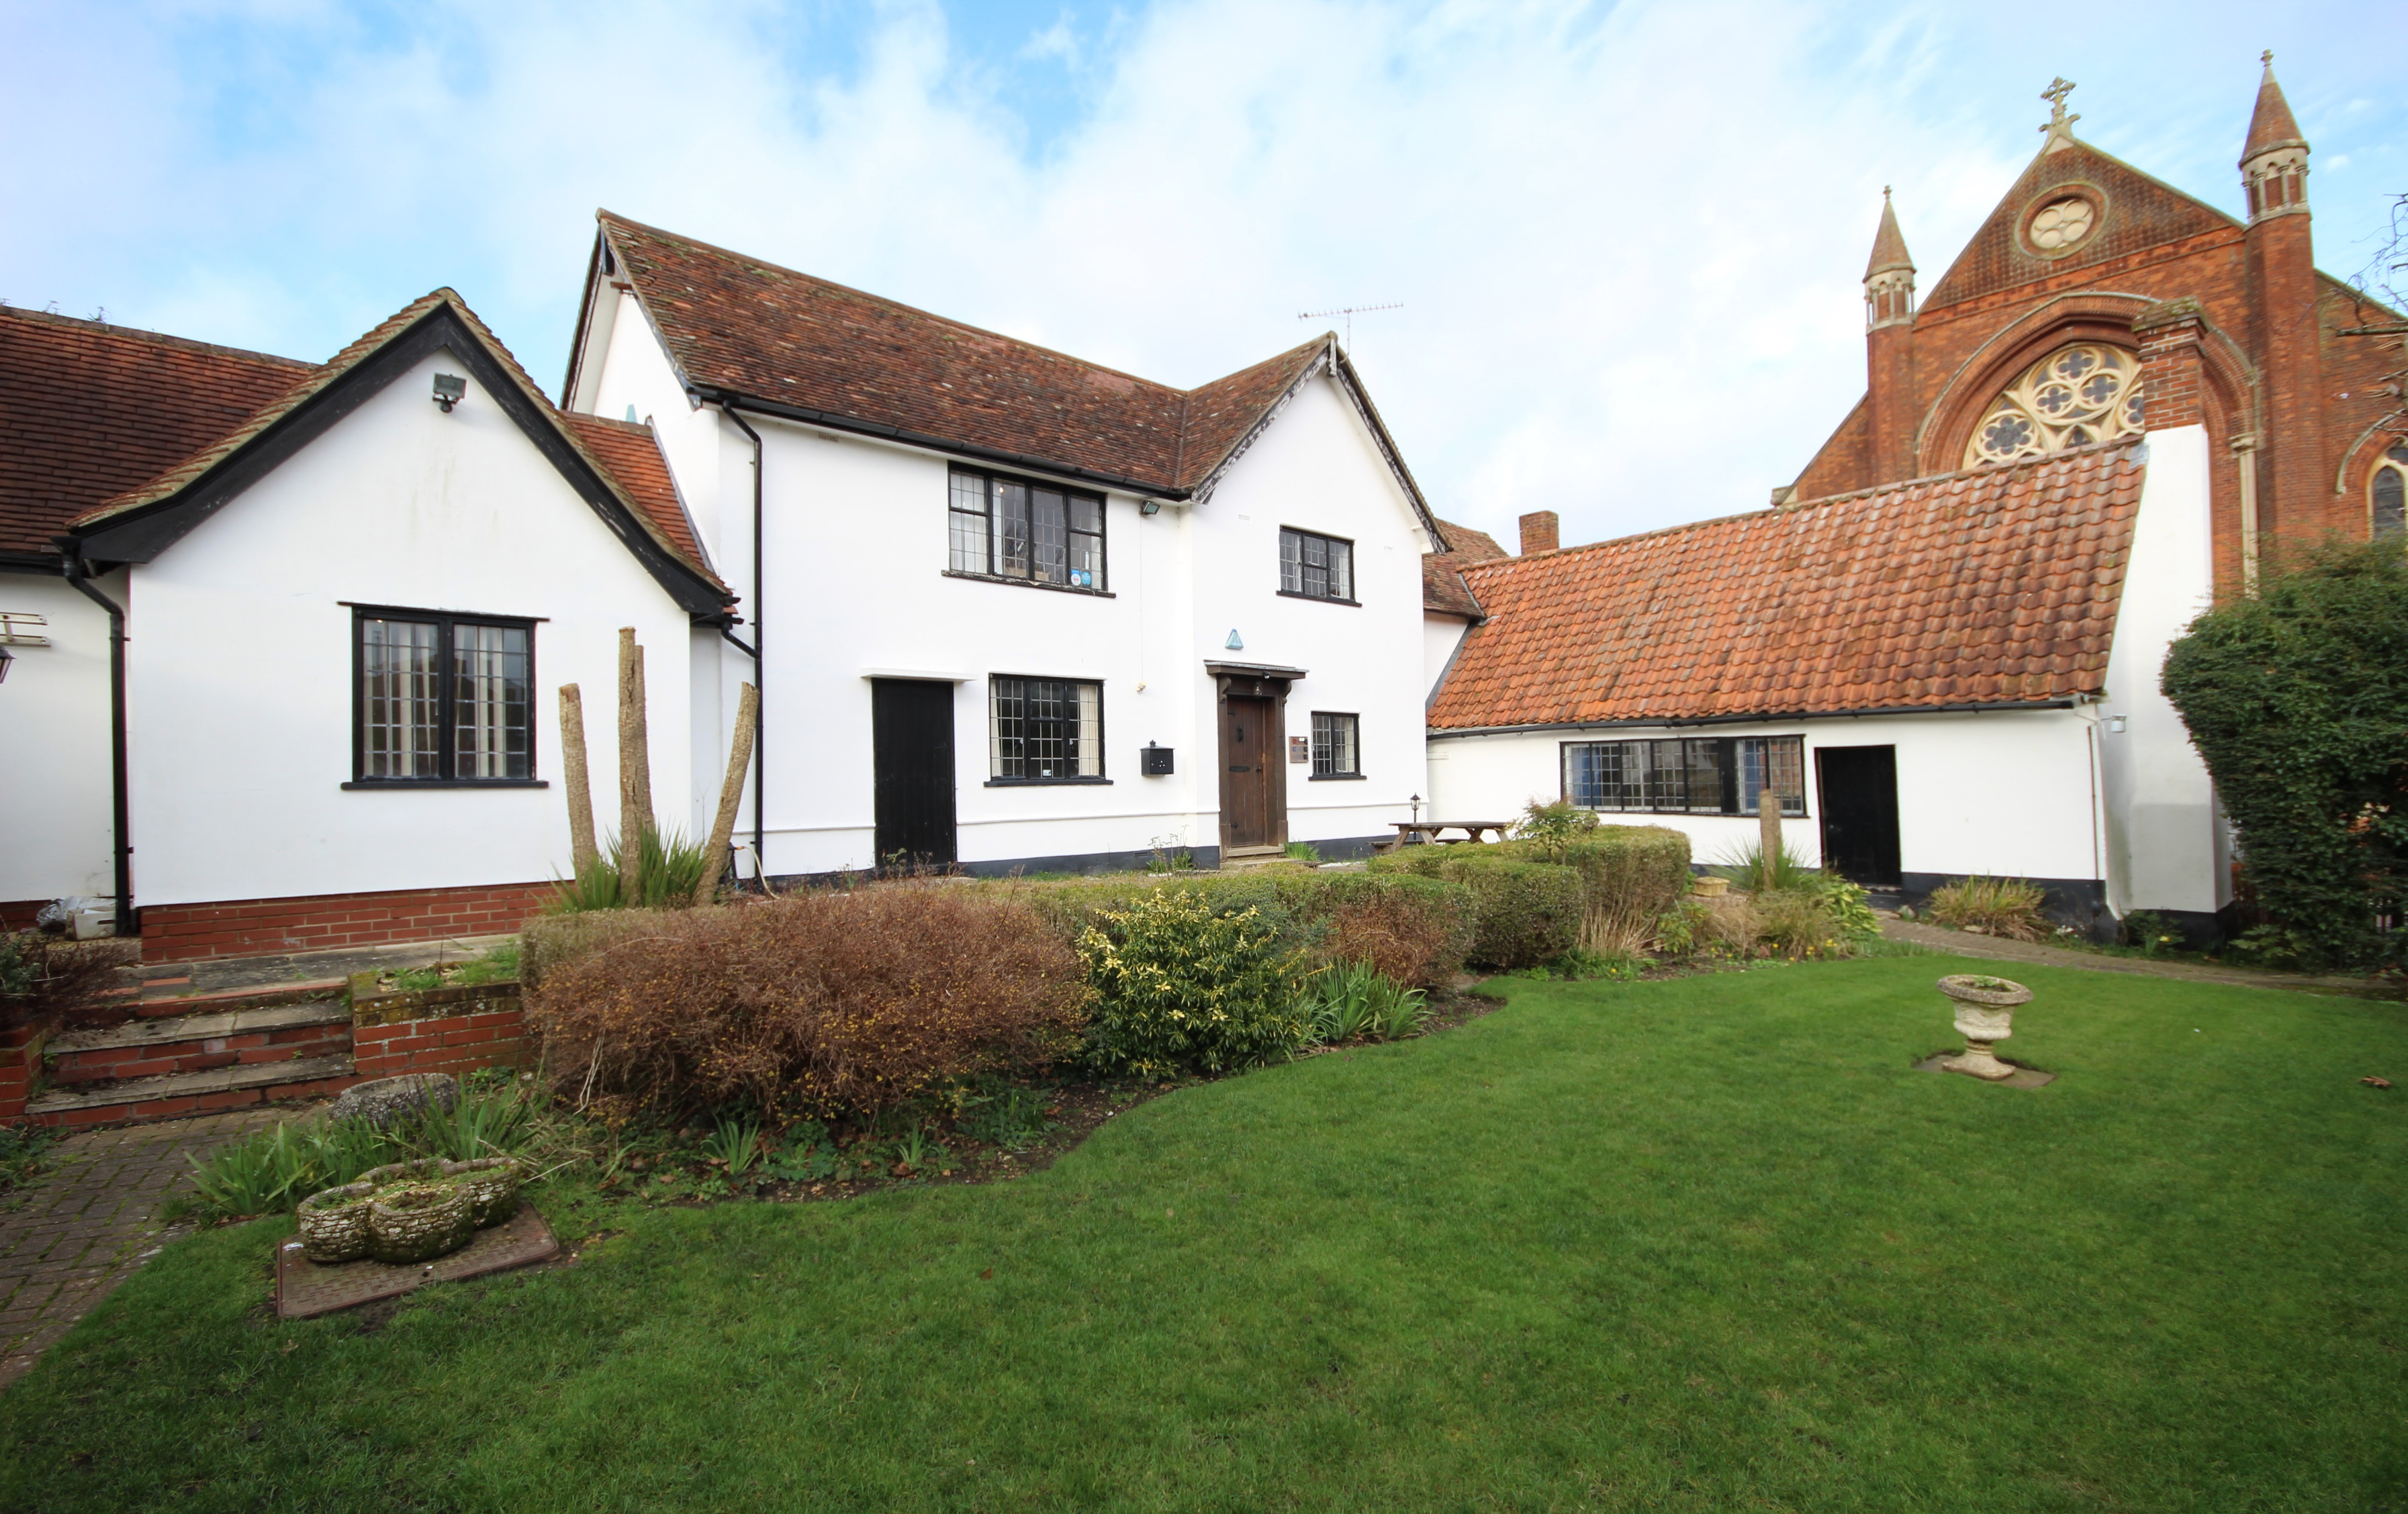

Hamlet Road, Haverhill
£599,995 Freehold

Weavers, Hamlet Road, Haverhill, Suffolk, CB9 8EE

Weavers is believed to be one of the oldest properties in Haverhill with some parts of the property dating back to the 15th Century. Sadly a fire destroyed many of Haverhill’s Medieval buildings in 1665 but glimpses can still be seen in Hamlet Road including Weavers.
The Weavers is a Medieval Hall House dating from the 15th Century. The property boasts a wealth of infinite character and charm throughout, this is especially noticed in the oldest part of the property which fronts onto Hamlet Road. Weavers is located close to the town centre and Samuel’s Estate Agents are pleased to offer for sale this Grade II listed detached property currently used for commercial use. But would make an ideal residence or even conversion into a number of residences subject to usual planning consents. Accommodation currently includes kitchen, reception area, main office room, three WC’s, two meeting rooms, the former Weavers room, three offices, gardens and off-street parking for many vehicles.
An internal viewing is highly recommended to appreciate the accommodation on offer.

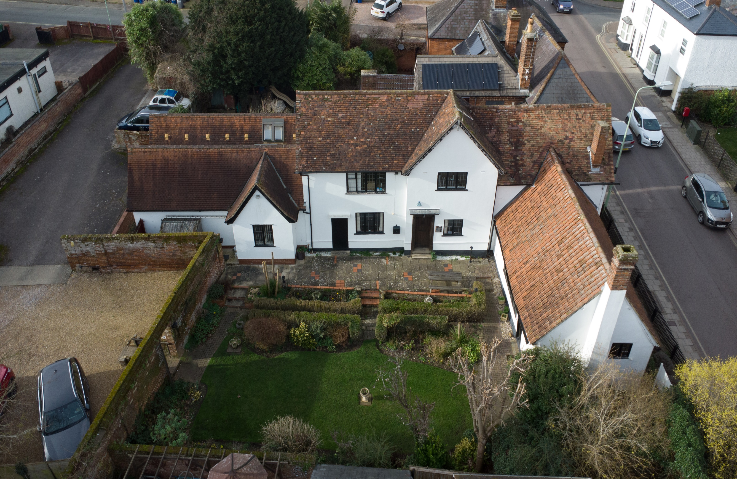

Ground Floor

Entrance Hall: Leaded window to side elevation, stairs to first floor landing, radiator.

Kitchen: 7’7 x 5’0 (2.31m x1.52m): Leaded light window to side elevation with cupboards beneath, stainless steel sink drainer unit, ceramic tiled splashbacks, ceramic tiled flooring and walk in cupboard housing combi Worcester boiler system.

Reception Area: 18’0 x 14’0 (5.49m x 4.27m): Leaded window to side elevation, radiator, two corner storage cupboards and stairs up to glazed panel doors leading to:

Main Office Room: 30’5 x 21’10 (9.27m x 6.65m): Leaded windows to rear and side elevations, Velux windows, four radiators, fire escape door.

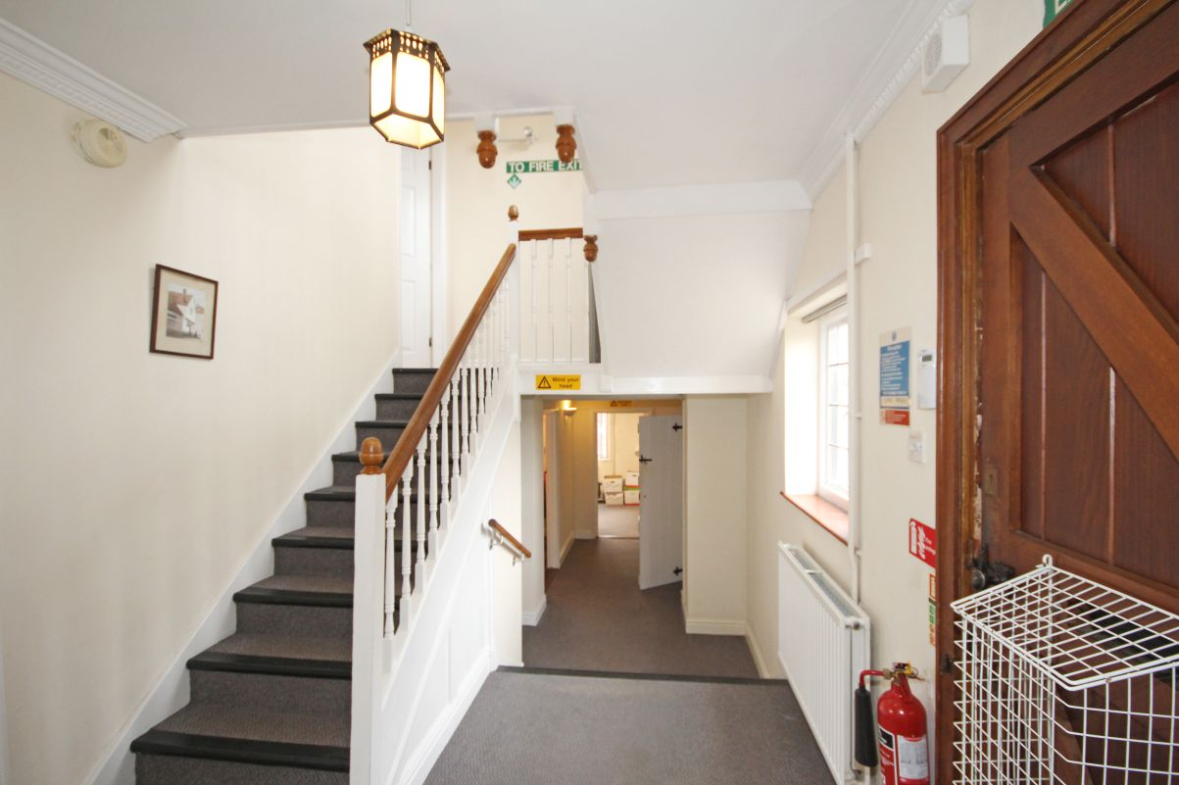
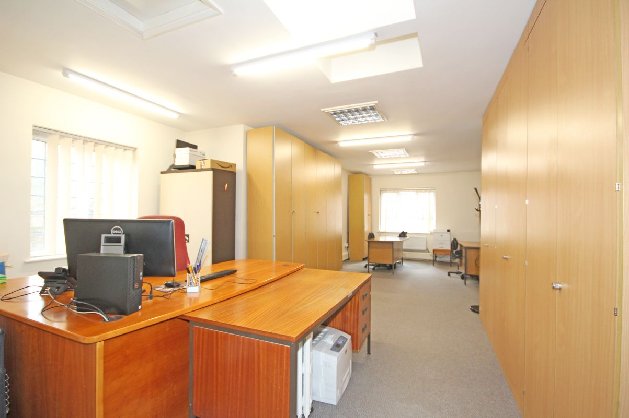
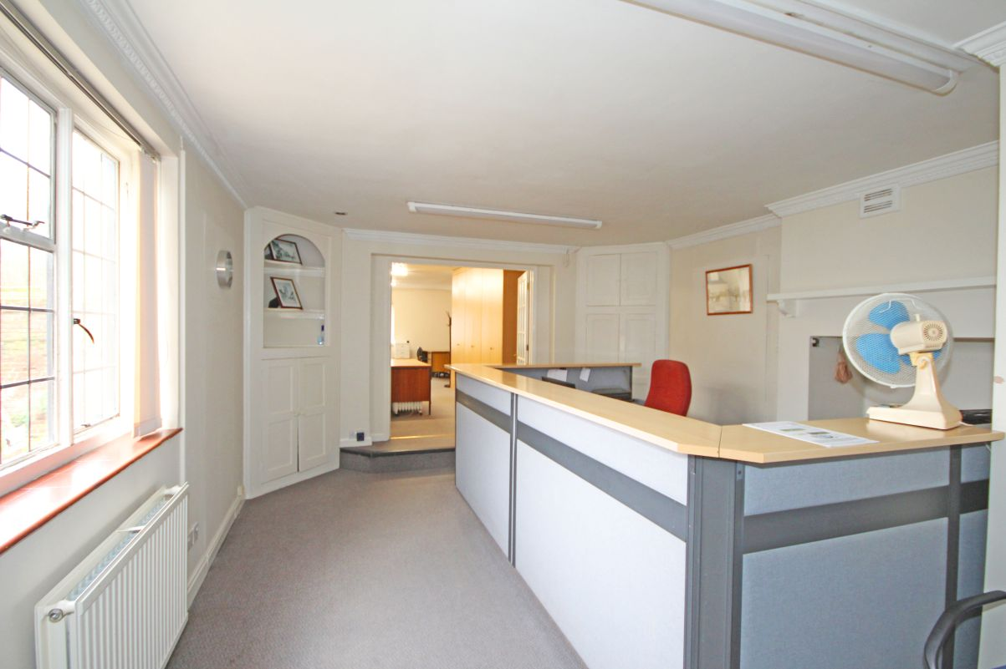
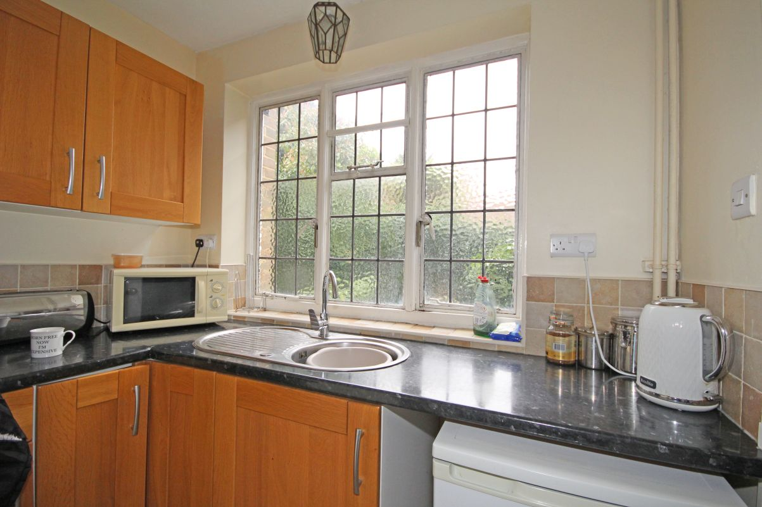
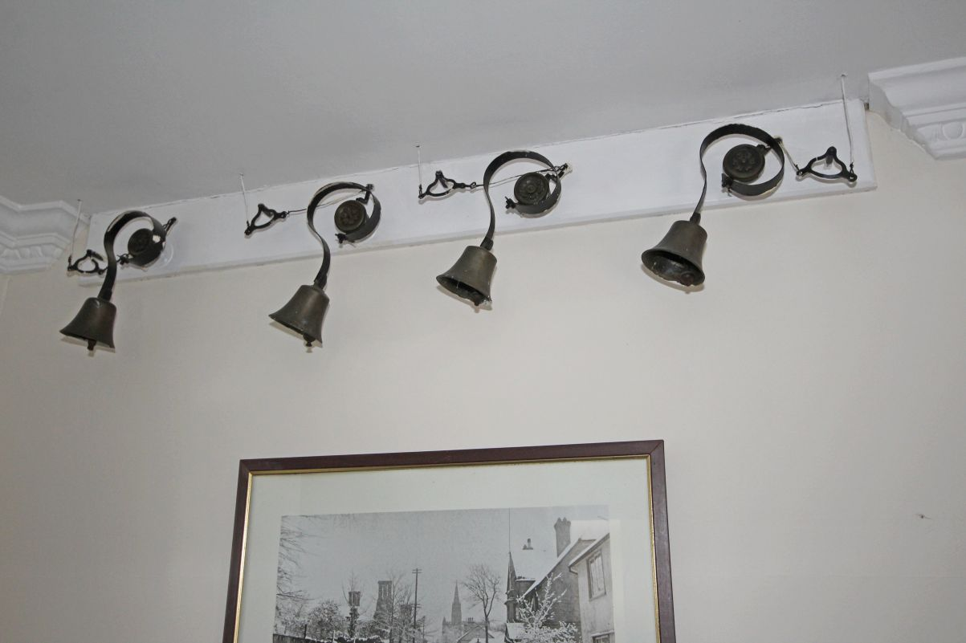

Lower-Level Hallway: Under stair recess area and stairs up to entrance hall.

Ladies WC: Leaded window to rear elevation, radiator, suite comprising low level WC and pedestal wash hand basin, wall mounted fan heater, ceramic tiled flooring.

Meeting Room: 9’0 x 8’3 (2.74m x 2.51m): Window to side elevation, radiator.

Office: 12’3 x 11’0 (3.73m x 3.35m): Leaded window to front elevation radiator.

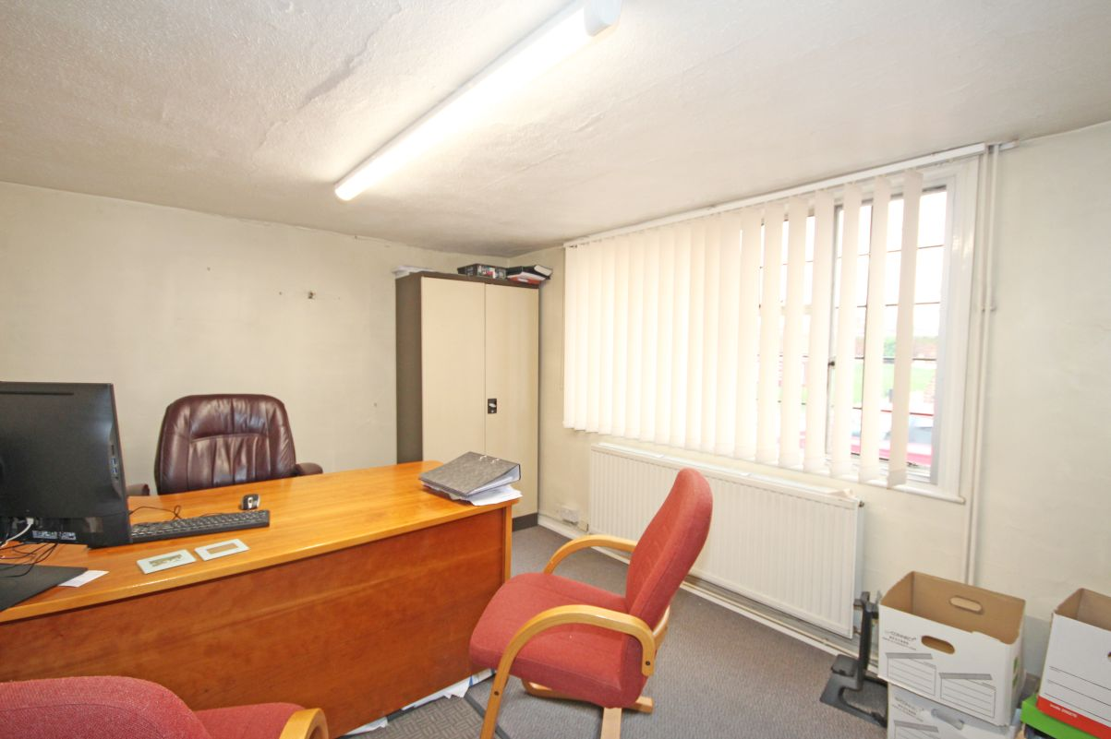

Former Weavers Room: 27’8 x 15’9 (8.43m x 4.8m): Leaded windows to front and rear elevation and timber door to rear, exposed timbers and four radiators.

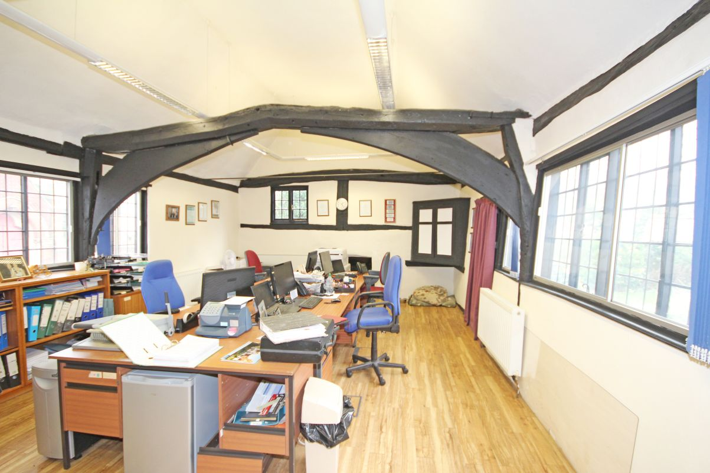

First Floor

Landing: stairs to second landing.

Gentlemen’s WC: Leaded window to side elevation with suite comprising low level WC, urinal and wash hand basin, tiled splash backs, radiator.

Office: 10’7 x 8’6 (3.23m x 2.6m): Window to side elevation, exposed timbers and radiator.

Meeting Room: 14’7 x 10’11 (4.45m x 3.33m): Leaded window to front elevation, exposed timbers and beams, exposed chimney breast, radiator.

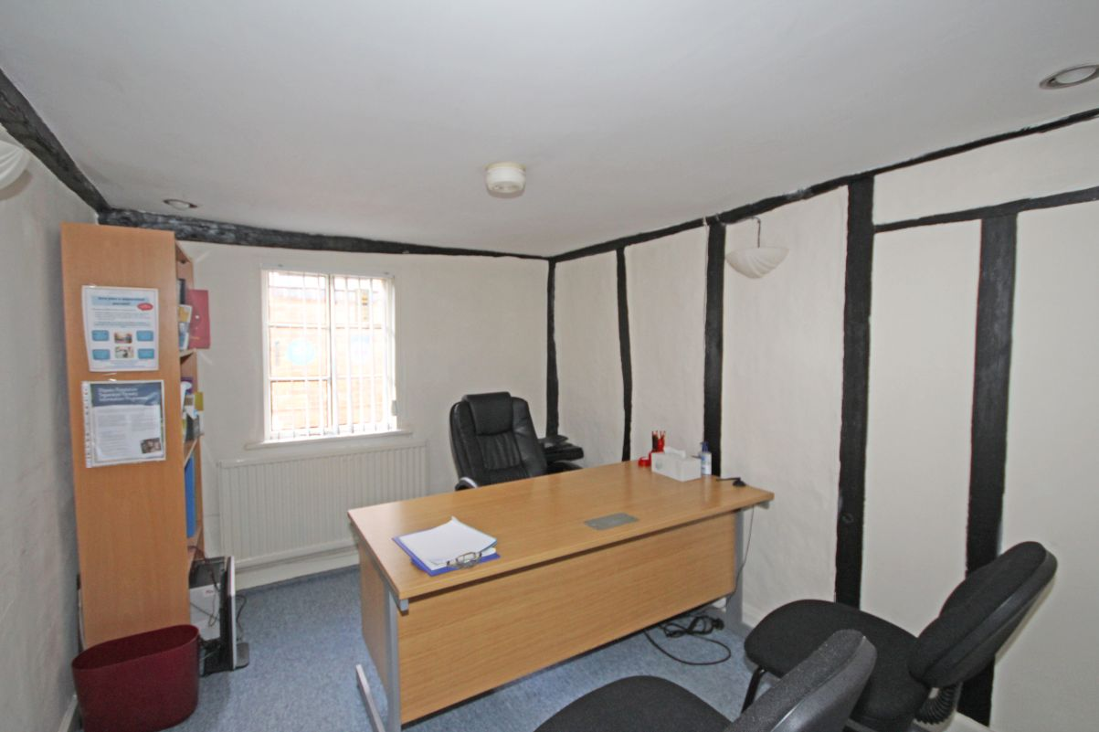
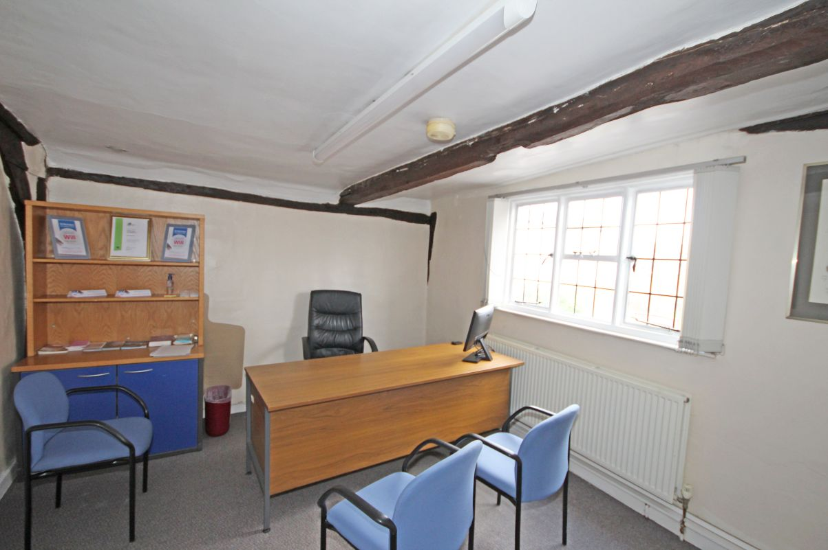

Second Floor

Landing: Leaded window to side elevation, radiator.

Ladies WC: Leaded window to side elevation, suite comprising low level WC, wall mounted wash hand basin, storage cupboards, access to roof space.

Office: 18’4 x 14’0 (5.49m x 4.27m): Leaded windows to front and rear elevations, radiator.

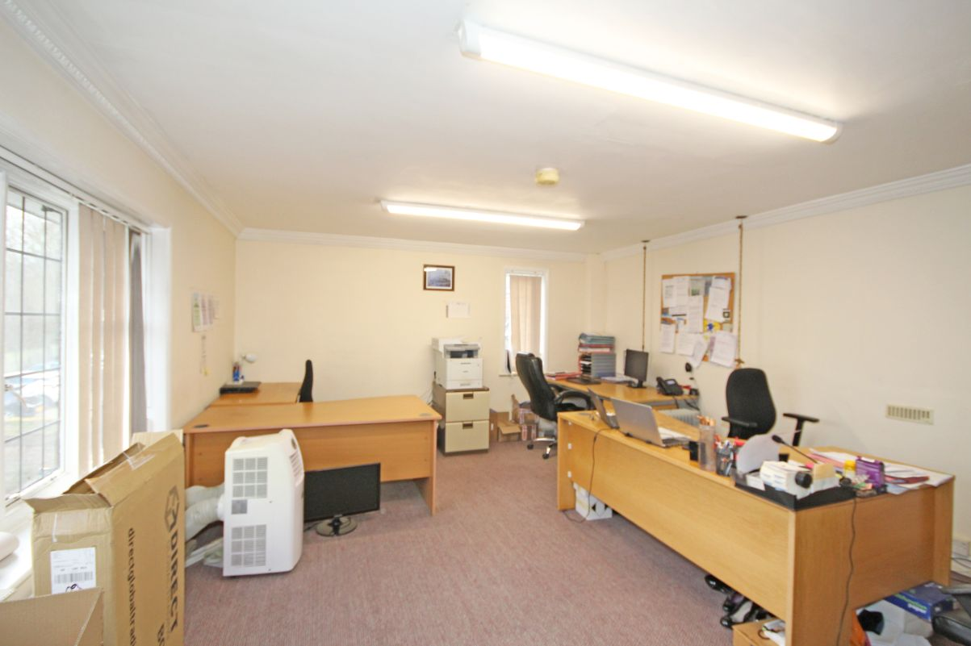

Exterior

Off Street Parking: Parking access via Colne Valley Road providing hard standing parking.

Gardens: Walled cottage garden, paved patio area with steps leading down to lawned area, flower beds, boards and a wealth of established shrubs and trees, access to front and rear of the property, thatched garden shed and further garden shed and outside lighting.

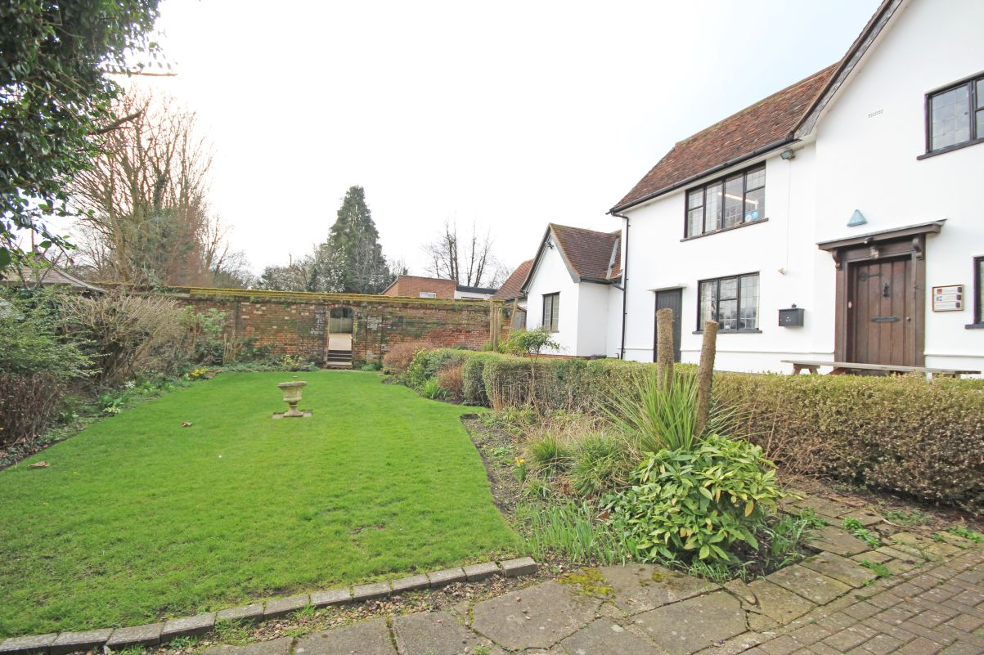
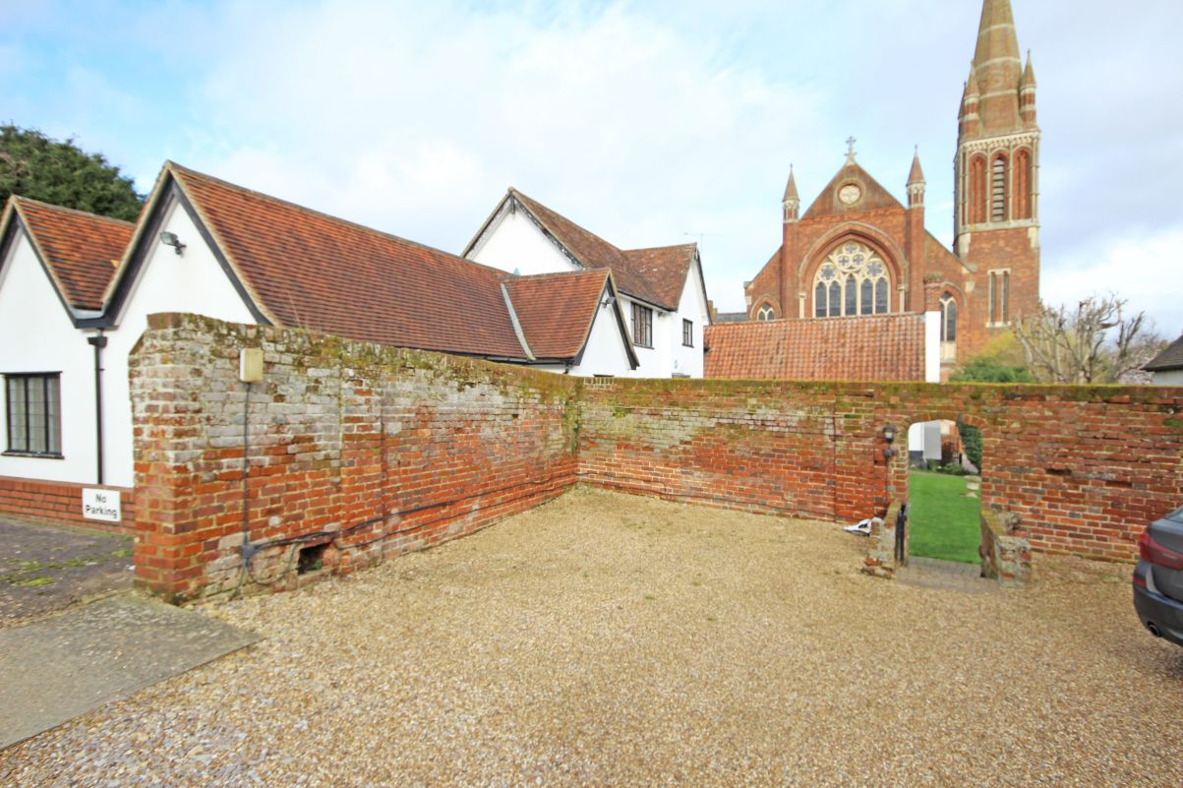
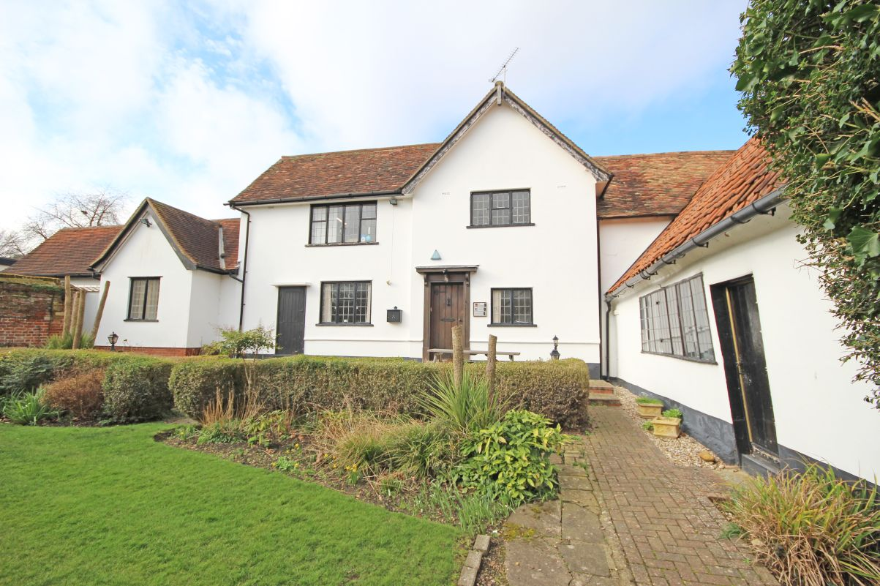
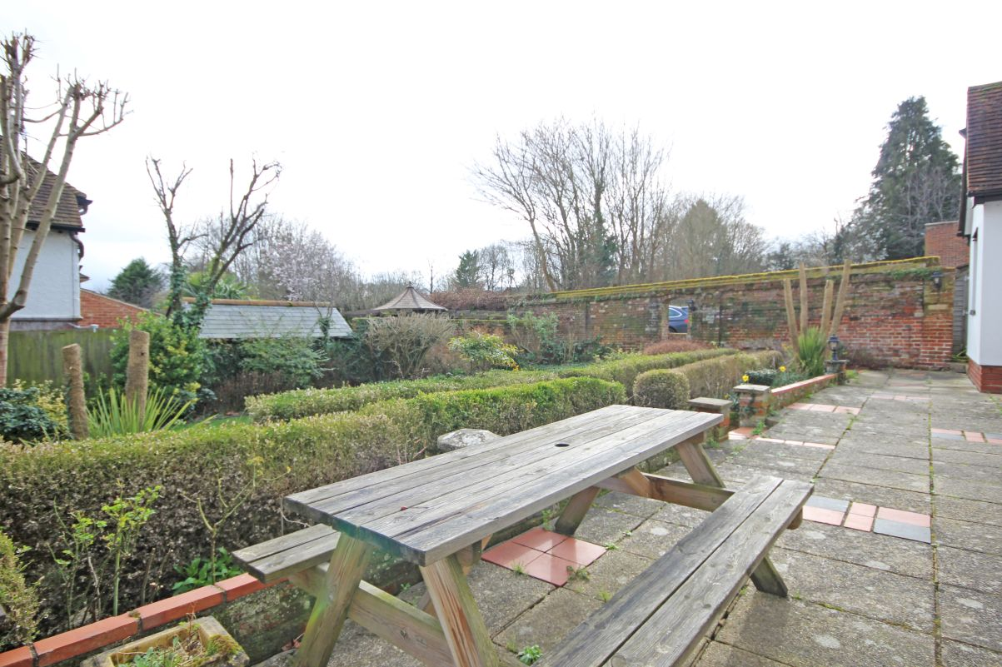
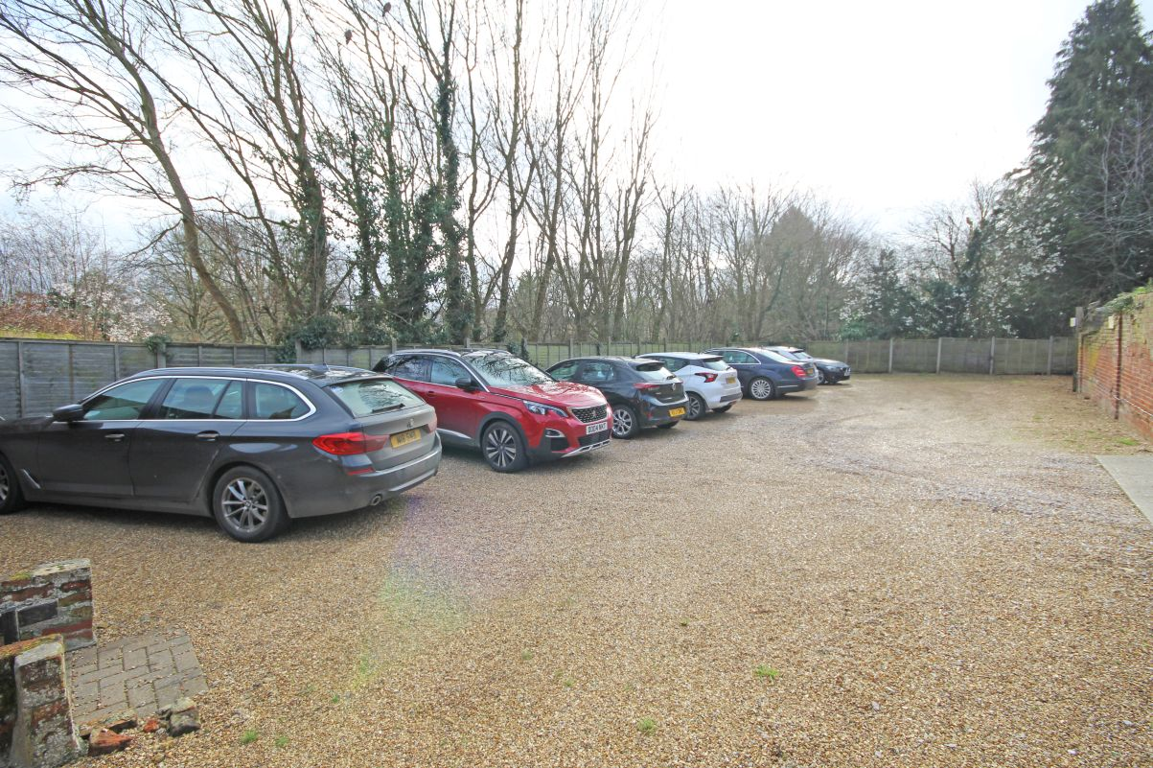
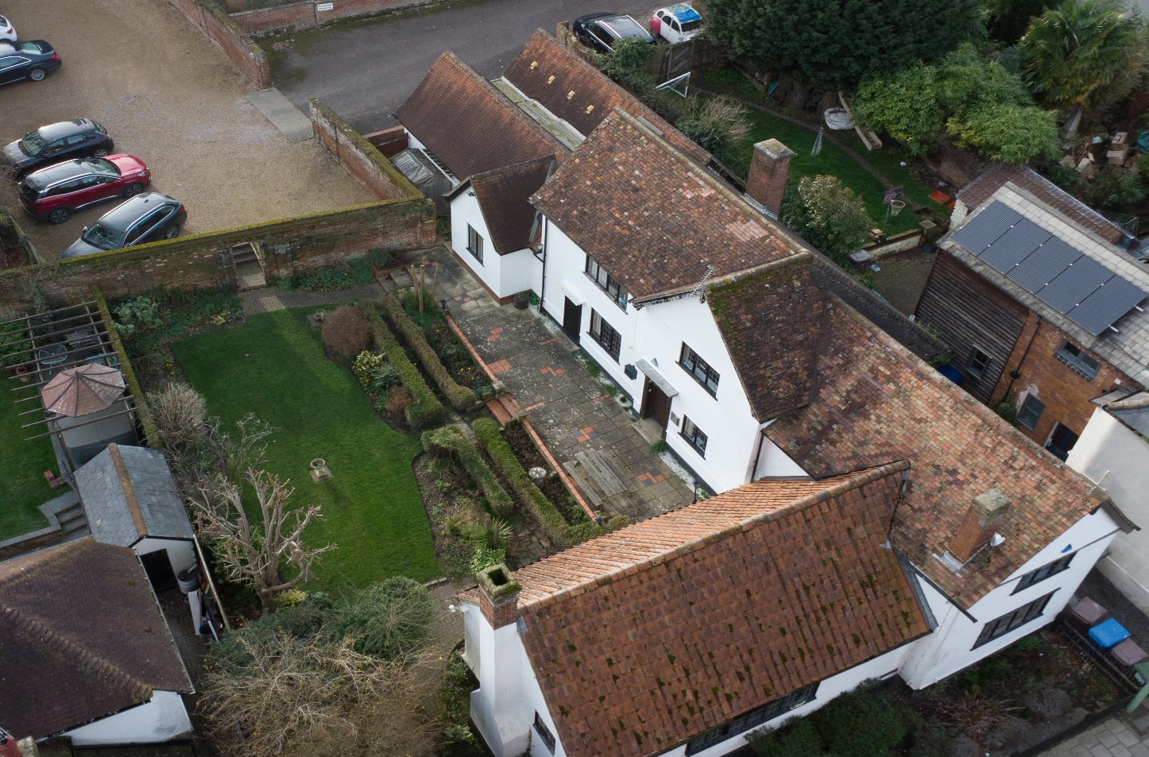

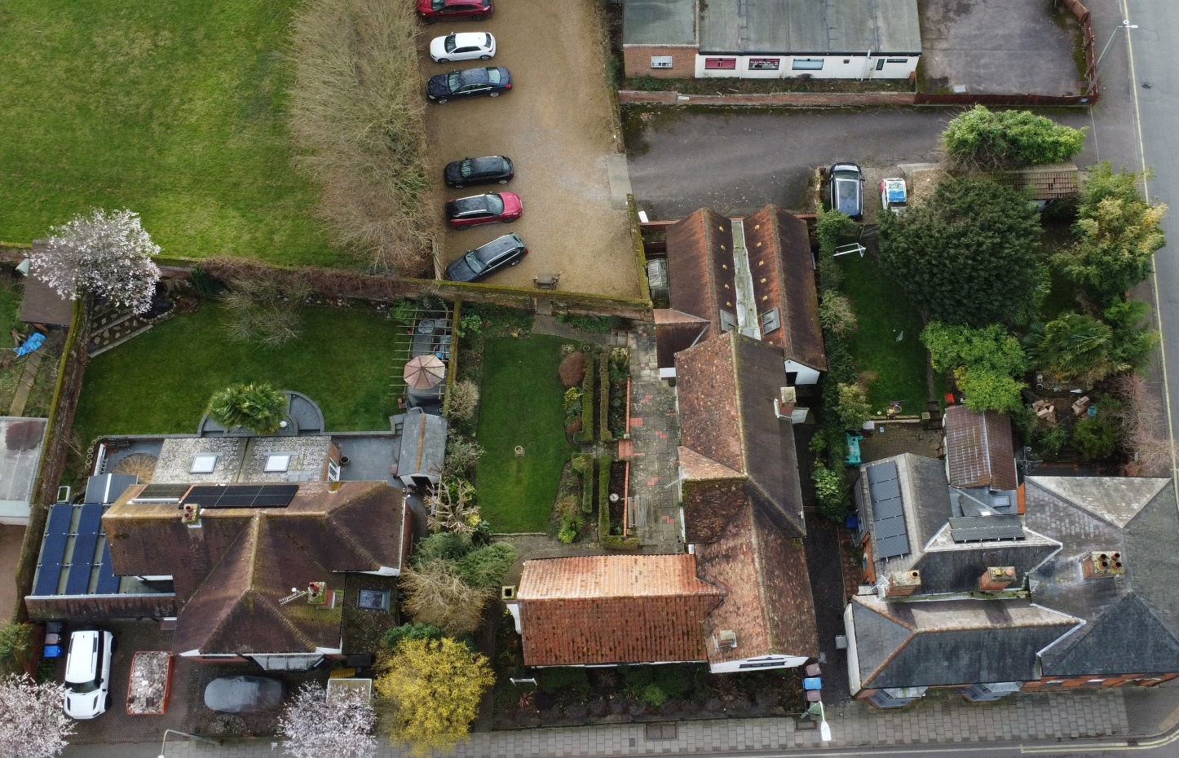
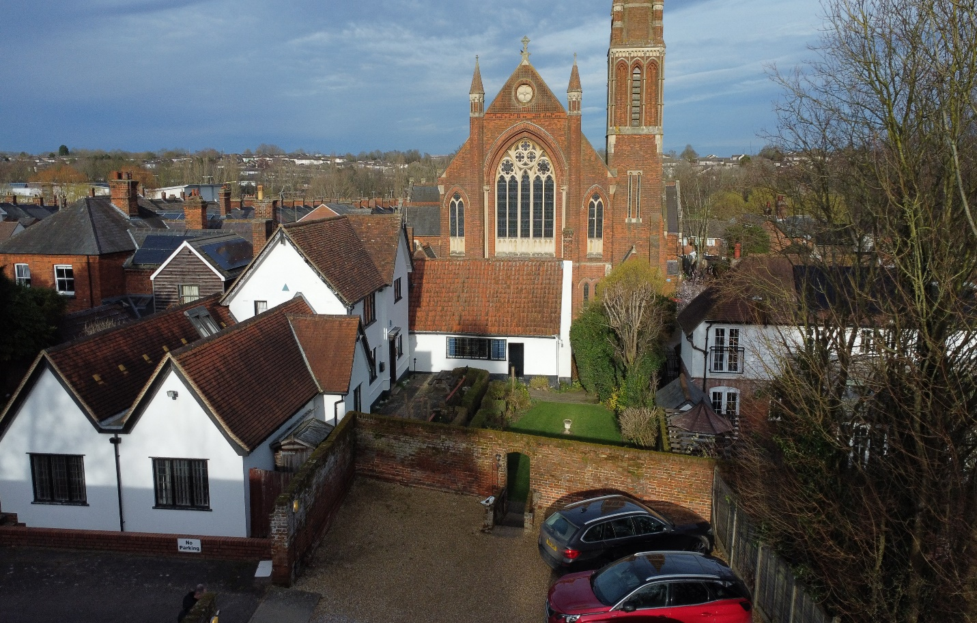
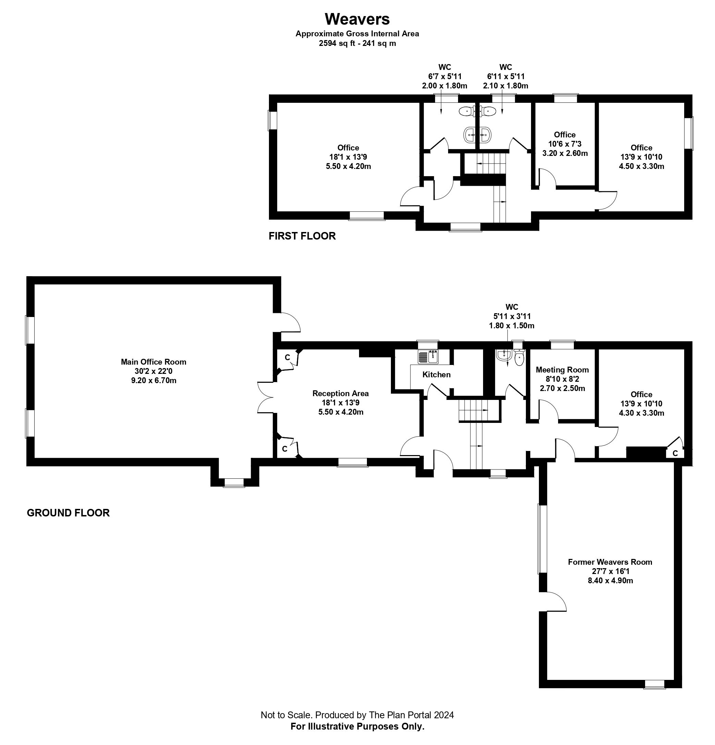

I hereby confirm that the information contained in these particulars is correct to the best of my knowledge and that any fixtures and fittings mentioned are in full working order unless otherwise stated.

Signed ________ _____

Date

Additional Information

Local Authority – West Suffolk Council
Council Tax - TBC

WE HAVE FOR YOUR CONVENIENCE A MORTGAGE ADVISOR TO OFFER FREE AND INDEPENDENT MORTGAGE ADVICE

AGENTS NOTE

None of the services, appliances or heating installations have been tested by the selling agent. Fixtures and fittings are excluded unless specifically mentioned. Items in photographs are not necessarily included. Floorplans are produced for illustration purposes only and are in no way a scale representation of the accommodation. All dimensions are approximate
As the sellers agents we are not obliged to carry out a full survey and are not conveyancing experts, as such we cannot & do not comment on the condition of the property or issues relating to title or other legal issues that may affect this property, unless we have been made aware of such matters. Interested parties should employ their own professionals to make such enquiries before making any transactional decisions.
These sales particulars do not constitute a contract or part of a contract.


All Viewings to be arranged via our office at:
1 Queen Street, Haverhill, Suffolk, CB9 9DZ

01440 708100

