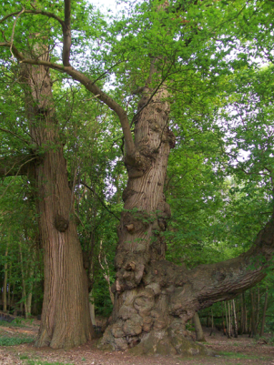
Braintree District Council
Landscape Services
Causeway House
Bocking End
Braintree
CM7 9HB

TO: Development Management

Ref. No. | 23/01994/FUL
Proposal | Demolition of the existing buildings on site, and the erection of a 64no. bed care home (Use Class C2), together with access, car parking, landscaping and associated works.
Site Address: | The Woodlands Hotel, Coupals Road, Sturmer, CB9 7UW
Case Officer | Carol Wallis
Responding Officer | James Remmington
Date | 09/10/2024

LANDSCAPE SERVICES ADVICE

Statutory or special tree considerations:
No TPOs at this address
Not within a Conservation Area

Comments:
Following previous comments, further information has been provided, including a revised Arboricultural Impact Assessment dated Sept 24, although still titled Rev B, and significant additional landscaping detail.

The revised AIA provides further information on the level of tree removal, with total losses, including trees within groups at 49 stems. The AIA also shows that minor layout changes have been incorporated to reduce previous RPA encroachment of concern, e.g T18 is now unaffected.
It also appears that the plan for parking adjacent trees has changed, for example T23 still has significant RPA encroachment, but this parking is now shown as “porous” on supporting drawings although there is little information on what this means, the AIA itself states that this area will be “no-dig” there remains no discussion of site levels.
There is no longer a Tree Protection Plan included with the drawing.
The supporting landscaping information now includes a detailed planting layout for the whole site, which includes a varied species palate and broadly demonstrates that the planting is at appropriate spacing densities. Ideally, plans would also illustrate the ultimate special requirements of the trees to show that the planting is sustainable through future growth, and would also include a design statement setting out justification for species choice in relation to site characteristics and design objectives. There is no detailed planting work specification, or plan of aftercare.
The landscape plan includes details of the wildflower mix proposed for the biodiverse roof, but states that details of construction are provided elsewhere.
There remains little information on the proposed management works within the woodland area, some indicative informal paths are shown, and are described as being potentially “no dig” or “compacted earth”, but nothing that would constitute a management plan.

Conclusion
The cumulative impacts to trees remain significant. There is substantial loss of trees, both individual and within groups, albeit largely of low size and quality.
Impacts to retained trees appear improved, but there is insufficient information to fully allay concerns.
Detail on new planting is substantially increased, and broadly demonstrates that new planting is feasible and likely to offer commensurate value to those removed, but further detail is still outstanding.
Similarly, there remains a lack of detail to demonstrate that a biodiverse roof is likely to be successful.

The level of information provided is improved, and there can now be some confidence that the impacts of the proposal can be effectively mitigated. Ideally at this stage further detail on level changes and a preliminary Tree Protection Plan would be provided to show that concerns regarding working room and the feasibility of mitigation have been addressed.

However, should the balance be in favour, conditions should be attached to secure:
- Full details of tree protection during construction, including a method statement following guidance set out in BS5837
- Full details of tree planting including planting methods and aftercare, following guidance set out in BS8545
- Full details of the proposed biodiverse roof, including construction, substrate and maintenance.
- Compliance with the above conditions

