

MOTTS FIELD PLAYZONE
PLANNING STATEMENT

In support of the construction of the Playzone.

Located at: Motts Field, Corner of A143 & Chalkstone Way

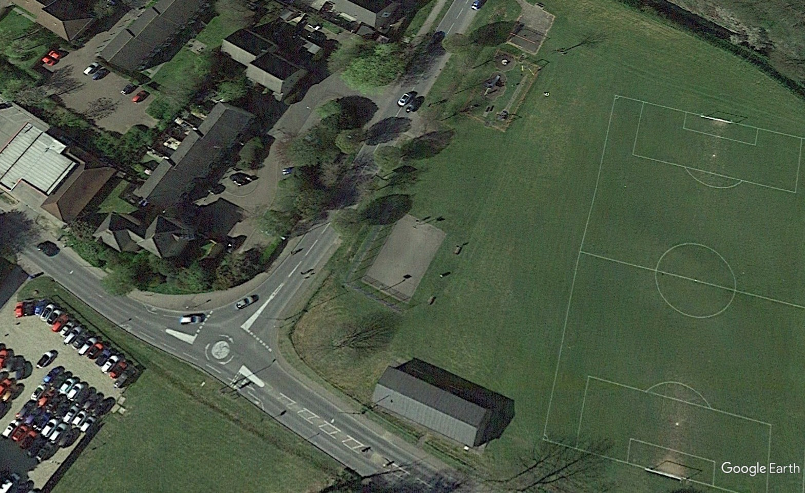

Ref: MCA-MUK3386-DAS Rev -

Date: 11-04-25

MUGA-UK LTD
Mill Farm, Hathern Road, Shepshed, Leicestershire LE12 9RP
T: 01509 503408
F: 01509 506420
E: info@muga-uk.co.uk W: www.muga-uk.co.uk

- INTRODUCTION
This statement is provided in support of the planning application to construction of a PlayZone (multi-use games area) which includes the following: new sports fencing, floodlight columns with LED lamps, macadam spectator area with benches & bins and PlayZone signage

This proposal will improve the facilities available at the site especially through the winter months and encourage a wider range of participants.

This statement briefly analyses the characteristics of the site and surrounding area and is to be read in conjunction with the associated proposed planning drawings.

- STATEMENT OF NEED
Through consultation, Motts Field was chosen as a site that would benefit from the
construction of a PlayZone facility.

The PlayZone Programme has been developed to tackle inequalities in physical activity and access to high quality facilities in targeted areas, by The Football Foundation providing funding towards community led spaces. The purpose of the PlayZone Scheme is to invest in areas with the greatest need, with the aim of encouraging specific priority groups to be more active.

The specific priority groups that The Football Foundation wished to prioritise as part of this scheme are: Lower Socio-Economic Groups, Women and Girls, Disabled people and people with long term health conditions, and ethnically diverse communities.

Further information about The Football Foundation – PlayZone Programme can be found
at: https://footballfoundation.org.uk/playzones-programme

Benefits arising from this project

This proposal aims to create a facility which supports the delivery of high-quality sport and recreational play by:-

- Providing a good quality facility that can be used when natural daylight is limited, especially for evening matches.

- Allowing standards in performance to be raised, encourage good social interaction and a general improvement in overall health.

- Providing the opportunity to periodically arrange specialised coaching sessions when natural daylight is limited to further improve skills and performance standards of users.

Current Opening Hours:

The PlayZone along with other facilities are currently available all week until 10pm, therefore this application does not seek to extend the current usage. The Playzone has an electronic gate lock system where users book online, this controls the usage of the site.

3.0 LOCATION

Motts Field site is located on the corner of the A143 and Chalkstone Way. It has a residential buildings to the west, industrial estate to the south, playing fields to the east and childrens play area to the north

Below the red rectangle shows the proposed location of the PlayZone

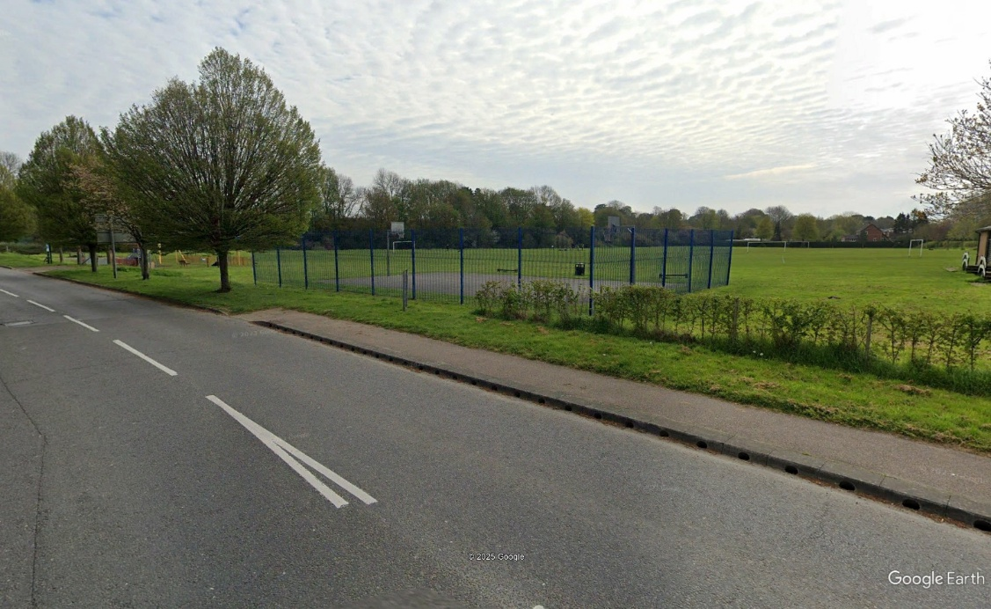

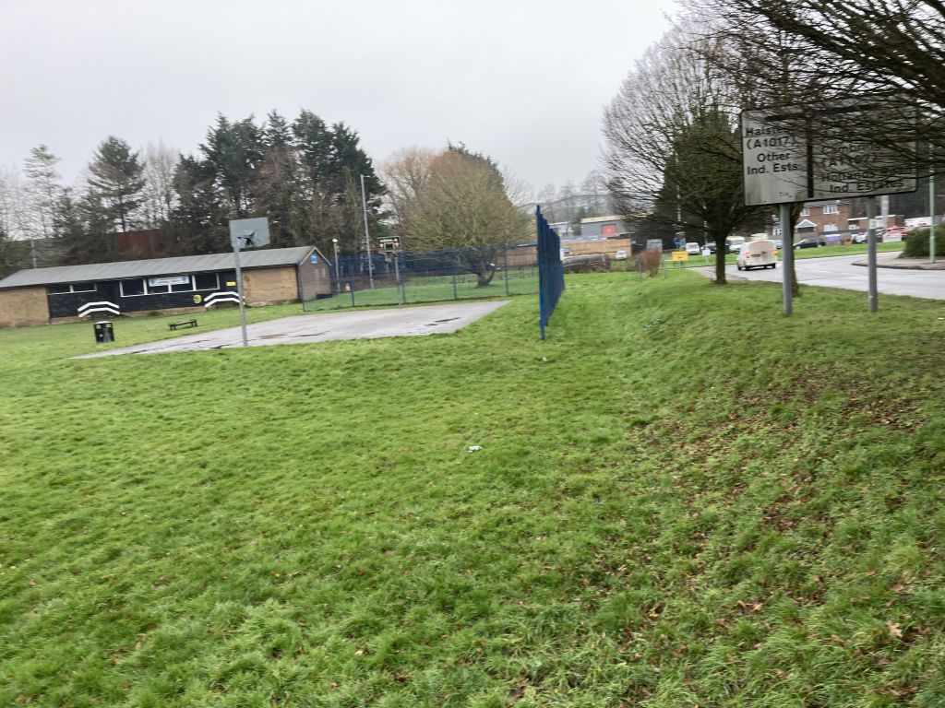

Views of the existing ball court

4.0 PROPOSAL DESIGN
The proposal takes the form of the following:

Fence-to-fence dimensions will be 30.0 x 20.0m, with additional 3.66 x 1.0m goal recess areas at each end.
Additional the remaining area will be resurfaced in macadam to provide safe standing area for people not inside the facility

Access will be via a new macadam path to the south of the playzone off Chalkstone Way.

Proposed gradients of the site are matching the existing area in the proposed location, with marrying in of the PlayZone to the existing hardstanding surround.

The proposals include what the Football Foundation consider to be a ‘standard size’ PlayZone, with all ancillary features and sporting equipment as standard to produce a facility that has sufficient and appropriate accessibility.

The proposed construction layers of the PlayZone is:
· 65mm two layer colour coated porous macadam
· 250mm SUB BASE LAYER
· Formation Layer

The proposed construction layers of the Spectator Area / Access is:
· 65mm two layer porous macadam
· 250mm SUB BASE LAYER
· Formation Layer

The construction layers have been determined following intrusive surveys of the existing construction make-up of the area, to dictate what levels of works were required to produce a suitable base for the PlayZone facility. The proposals and quantities above have been suggested to ensure that the facility is built in line with relevant construction technical data for these types of facility, to ensure the PlayZone is built to a high standard at the outset and will remain a high-class facility for years to come.
Surface Layer
The proposed surface layer is a porous macadam with colour coat paint finish. The facility will be tested upon completion, with the surface required to meet EN 15330-1.

The surface will have markings for recreational Football, Basketball & volleyball specific applications.

The Football Association and Basketball have suggested that for a PlayZone a macadam surface would be the preferred surface type. The Community Engagement feedback received has therefore been used to dictate the design of the construction for this site.

Surface water drainage
Currently, the surface is a non-porous macadam surface, with no formal drainage system installed. The proposals include re-building the area with porous materials to create a water compatible development.

In conclusion, the new development will mimic the existing development.

Perimeter fencing
This PlayZone has been designed to include 3.0m high twin bar paneled fencing around the synthetic turf footprint of the PlayZone, with double rebound mesh to the bottom 1.2m of fencing. The height is proposed to increase behind the goals and net posts to 4.0m high.

The PlayZone has been designed to include 1Nr user entrance / exits, including 1Nr double gate entrance (with additional gates for storage cage). These gates are proposed to work on an electronic access system, which will provide access (and floodlighting) to users that have booked the use of the facility via a code.

The fencing is designed to be ‘RAL 6005 – Moss Green’ colour around the perimeter of the PlayZone, with a ‘RAL 9016 – White’ colour to the goal area.

We have provided associated drawing showing the scale and location of the proposed fencing.

Fence heights have been designed as per the Football & Basketball fencing requirements for a PlayZone.

The gates are as per relevant access guidance for facilities of this nature. The proposed electronic access system is in line with PlayZone facility requirements. Fencing colour scheme has been designed to minimise the visual impact of the PlayZone on the local surroundings where possible.

We have included an indicative photo below of the proposed fencing system. (please note this is a visual aid, and its inclusion is to provide an image of the general appearance of the proposed fencing system, and therefore should not be taken as ‘scaled’)

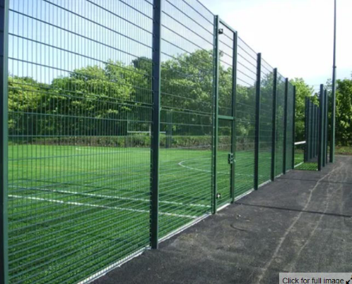

LED floodlighting system
This PlayZone has been designed to include 8.0m high fence fixed LED Floodlighting System, consisting of 4Nr fence fixed luminaire on the four corners of the PlayZone (4Nr luminaires total).

Please refer to the MUK3386 – floodlighting scheme document for more details on the spillage

We have provided associated drawing showing the scale and location of the proposed floodlighting system.

A lighting design also accompanies this planning application.

We have included an indicative photo below of the proposed fence fixed floodlighting system.
(please note this is a visual aid, and its inclusion is to provide an image of the general appearance of the proposed fencing system, and therefore should not be taken as ‘scaled’)

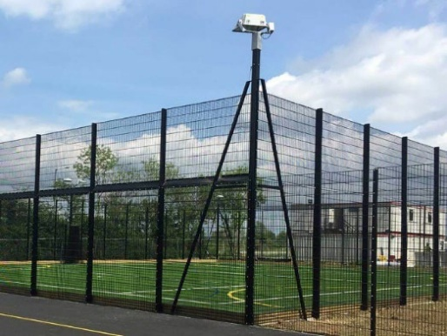

Equipment
Goals
This PlayZone has been designed with 1Nr fence incorporated goal at each end of the site.

Basketball Systems
This PlayZone has been designed with incorporated basketball system at each end of the site above the football goal.

Basketball
Four basketball hoops for small sided basketball (no lines)

Benches
This PlayZone has been designed with 2Nr benches incorporated within the spectator area for people who are not inside of the fenced footprint of the facility.

Electronic Access System
This PlayZone has been designed with electronic access system, as per design requirements of a PlayZone facility, to provide bookable access to potential users of the facility. (in line with feedback received from potential user groups detailing that bookable access provides an element of safety of use of outdoor facilities in comparison to unbookable facilities)
National Planning Policies

General
The National Planning Policy Framework sets out the Government’s planning policies for England and how these are expected to be applied. It sets out the Government’s requirements for the planning system, only to the extent that it is relevant, proportionate and necessary to do so. It provides a framework within which local people and their accountable councils can produce their own distinctive local and neighbourhood plans, which reflect the needs and priorities of their communities.

We have highlighted what they feel to be some relevant National Planning Policies in regard to this particular development, and how we have addressed each policy within the design stage of this facility below.

The below is a brief summary of some of the key considerations that formed part of the design considerations in relation to this proposed development. This in no way suggests that other National Planning Policies have not been adhered to, but is used to show adherence to relevant policies formed a major part of the design stage.

Promoting healthy and safe communities
Par 92 – Planning Policies and decisions should aim to achieve health, inclusive and safe places which:
a) promote social interaction, including opportunities for meetings between people who might not otherwise come into contact with each other – for example through mixed-use developments, strong neighbourhood centres, street layouts that allow for easy pedestrian and cycle connections within and between neighbourhoods, and active street frontages;
b) are safe and accessible, so that crime and disorder, and the fear of crime, do not undermine the quality of life or community cohesion – for example through the use of attractive, well-designed, clear and legible pedestrian and cycle routes, and high-quality public space, which encourage the active and continual use of public areas; and
c) enable and support healthy lifestyles, especially where this would address identified local health and well-being needs – for example through the provision of safe and accessible green infrastructure, sports facilities, local shops, access to healthier food, allotments and layouts that encourage walking and cycling.
The proposed development has been designed to provide sports provision to the local
area. We therefore feel the proposals are aligned to Paragraph 92 of the NPPF in
particular the provision of sports facilities.

Par 93 – To provide the social, recreational and cultural facilities and services the community needs, planning policies and decisions should:
a) plan positively for the provision and use of shared spaces, community facilities (such as local shops, meeting places, sports venues, open space, cultural buildings, public houses and places of worship) and other local services to enhance the sustainability of communities and residential environments
b) take into account and support the delivery of local strategies to improve health, social and cultural well-being for all sections of the community
The proposed development has been designed to provide access to sporting provision including The Football Foundations core objectives of the PlayZone Scheme of identifying targeted priority groups including Lower Socio-Economic Groups, Women and Girls, Disabled people and people with long term health conditions, and ethnically diverse communities. We therefore feel the proposals are aligned to Paragraph 93 of the NPPF in particular the provision of a social and recreational facility for sporting use, which would aim to improve health and social well-being for all sections of the local community.

Par 98 – Access to a network of high-quality open spaces and opportunities for sport and physical activity is important for the health and well-being of communities, and can deliver wider benefits for nature and support efforts to address climate change.
Planning policies should be based on robust and up-to-date assessments of the need for open space, sport and recreation facilities (including quantitative or qualitative deficits or surpluses) and opportunities for new provision. Information gained from the assessments should be used to determine what open space, sport and recreational provision is needed, which plans should then seek to accommodate.
The proposed development has been designed to provide a high-quality space for sport
and physical activity to the local area. Local planning policies and community engagement show a need for this development.

Par 99 – Existing open space, sports and recreational buildings and land, including playing fields, should not be built on unless:
a) an assessment has been undertaken which has clearly shown the open space, buildings or land to be surplus to requirements; or
b) the loss resulting from the proposed development would be replaced by equivalent or better provision in terms of quantity and quality in a suitable location; or
c) the development is for alternative sports and recreational provision, the benefits of which clearly outweigh the loss of the current or former use.
The proposed development has been designed to have little / no impact on the existing
sporting provisions on the site, as shown by the associated drawings.

Achieving well-designed places
Par 126 – The creation of high-quality, beautiful and sustainable buildings and places is fundamental to what the planning and development process should achieve. Good design is a key aspect of sustainable development, creates better places in which to live and work and helps make development acceptable to communities. Being clear about design expectations, and how these will be tested, is essential for achieving this. So too is effective engagement between applicants, communities, local planning authorities and other interests throughout the process.
For every aspect of the design, materials have been suggested that are in keeping with usual typical build construction / appearance / formats for sporting applications.
We therefore feel the proposals align with Paragraph 126 of the NPPF in regard to the creation of high-quality sustainable facilities.

Par 130 – Planning policies and decisions should ensure that developments:
a) Will function well and add to the overall quality of the area, not just for the short term but over the lifetime of the development
b) Are visually attractive as a result of good architecture, layout and appropriate and effective landscaping
f) Create places that are safe, inclusive and accessible and which promote health and well-being, with a high standard of amenity for existing and future users
The design will produce a high-quality facility, with suitable construction make up for the lifetime of the development. We therefore feel that the area has been designed to be visually attractive in keeping with usual design appearances, and creates a facility that is safe, inclusive and accessible to the public.

Meeting the challenge of climate change, flooding and coastal changes
Par 153 – Plans should take a proactive approach to mitigating and adapting to climate
change, taking into account the long-term implications for flood risk, coastal change, water supply, biodiversity and landscapes, and the risk of overheating from rising temperatures. Policies should support appropriate measures to ensure the future resilience of communities and infrastructure to climate change impacts, such as providing space for physical protection measures, or making provision for the possible future relocation of vulnerable development and infrastructure.
The proposed development of a PlayZone facility is to provide an area for the public to
undertake healthy activity, with a minimum impact on the environment now and into the future. Consideration of flood risk has been duly accounted for in the design (and if
required location.)

Par 167 – When determining any planning applications, local planning authorities should
ensure that flood risk is not increased elsewhere. Where appropriate, applications should be supported by a site-specific flood-risk assessment. Development should only be allowed in areas at risk of flooding where, in the light of this assessment (and the sequential and exception tests, as applicable) it can be demonstrated that:
c) it incorporates sustainable drainage systems, unless there is clear evidence that this would be inappropriate
d) any residual risk can be safely managed
The proposed development and its design offers a suitable solution to minimising any flood risk to either the facility or the surrounding environment. A desktop Flood Risk Assessment has been undertaken to assure the facilities location is appropriate, and to influence the design.

Par 168 – Applications for some minor development and changes of use should not be subject to the sequential or exception tests but should still meet the requirements for site-specific flood risk assessments (explained in italics below):
A site-specific flood risk assessment should be provided for all development in Flood Zones 2 & 3. In Flood Zone 1, an assessment should accompany all proposals involving:
· Sites of 1 hectare or more (10,000m2)
· Land which has been identified by the Environment Agency as having critical drainage problems
· Land identified in a strategic flood risk assessment as being at increased flood risk in future
· Land that may be subject to other sources of flooding, where its development would introduce a more vulnerable use.

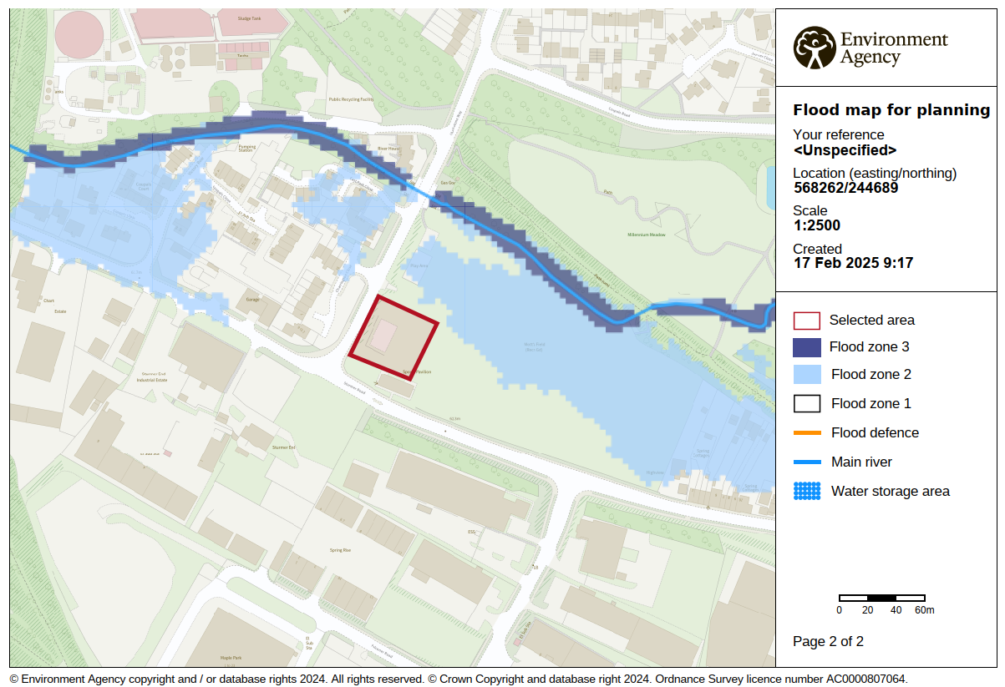

Flood Zone 1

Local Planning Policies

General
We have highlighted what they feel to be the most relevant Local Planning Policies in regard to this particular development, and how we have addressed each policy within the design stage of this facility below.

The below is a brief summary of some of the key considerations that formed part of the design considerations in relation to this proposed development. This in no way suggests that other National Planning Policies have not been adhered to, but is used to show adherence to relevant policies formed a major part of the design stage.

Open Spaces EN3
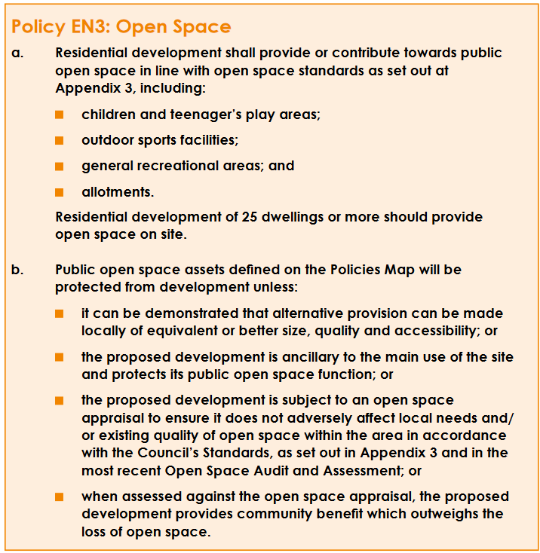

4.340 All open space of public value can be defined as primarily open land, whether green or hard surfaced, which offer important opportunities for sport and recreation and can act as a visual amenity. This includes parks and gardens, public amenity areas, play areas, allotments, private and public playing fields, rivers, lakes, canals, nature reserves and other outdoor sports provision such as bowling greens

The PlayZone meets the above policy

Sport England Playing Field Policy

Sport England will oppose the granting of planning permission for any development
which would lead to the loss of, or prejudice the use of:
· All or any part of a playing field, or
· Land which has been used as a playing field and remains undeveloped, or
· Land allocated for use as a playing field
Unless, in the judgement of Sport England, the development as a whole meets with one
or more of five specific exemptions detailed below:

Exception 1 (E1): A robust and up-to-date assessment has demonstrated, to the
satisfaction of Sport England, that there is an excess of playing field provision in the
catchment, which will remain the case should the development be permitted, and the
site has no special significance to the interests of sport

Exception 2 (E2): The proposed development is for ancillary facilities supporting the
principal use of the site as a playing field, and does not affect the quantity or quality of
playing pitches or otherwise adversely affect their use.

Exception 3 (E3): The proposed development affects only land incapable of forming
part of a playing pitch and does not:
· Reduce the size of any playing pitch, or
· Result in the inability to use any playing pitch (including the maintenance of
adequate safety margins and run-off areas), or
· Reduce the sporting capacity of the playing field to accommodate playing
pitches or the capability to rotate or reposition playing pitches to maintain
their quality, or
· Result in the loss of other sporting provision or ancillary facilities on the site, or
· Prejudice the use of any part of a playing field and any of its playing pitches

Exception 4 (E4): The area of playing field to be lose as a result of the proposed
development will be replaced, prior to the commencement of development, by a new
area of playing field:
· Of equivalent or better quality, and
· Of equivalent or greater quantity, and
· In a suitable location, and
· Subject to equivalent or better accessibility and management arrangements

Exception 5 (E5): The proposed development is for an indoor our outdoor facility for
sport, the provision of which would be of sufficient benefit to the development of sport
as to outweigh the detriment caused by the loss, or prejudice to the use, of the area of
playing field

We have designed the proposed PlayZone facility with the above policy in mind.
We feel the proposed development particularly meets E2, E3 and E5 requirements. The
proposed location is in an area under used / proposed to be used for sporting application and is sufficiently distanced from existing provisions on the site to not have an adverse effect on sporting provision on the site.

Community Engagement

There is a desire to create a PlayZone at Sandham Gardens due to local data and insight to identify neighborhoods of high need with regards to target groups.

The proposed PlayZone fits into the wider facility development plans.

Other reasons for this location are:
● Convenient location to the site entrance with street lighting to provide safe access
● Convenient proximity to welfare accommodation.
● Convenient proximity to management and supervision.
● Avoidance of unacceptable impact to residential neighbours (noise, visual and residential amenity) or the ability to introduce impact mitigation measures.
● Avoidance of unacceptable impact to any local biodiversity and ecology or the ability to introduce impact mitigation measures.

5.0 SUMMARY

We believe the development of a PlayZone in the proposed location will provide a high-quality sporting and activity space. The development aims to tackle inequalities in participation in sport and activity in the area.

The proposal would be of considerable benefit to the local community groups, through the provision of a new facility in a previously unused area.

The new facility has been designed with the aim of minimising impact to local residents / environment where possible, with drainage / fencing / floodlighting / access all designed with construction best practices in mind.

